CONTACT: Nancy Richards – 917-873-6389 (cell) /nancy@northcoastrep.org
MEDIA PAGE: www.northcoastrep.org/press
FOR IMMEDIATE RELEASE, PLEASE:

SENSITIVE ISSUES TACKLED WITH HUMOR AND COMPASSION
IN NORTH COAST REPERTORY THEATRE’S WEST COAST PREMIERE
OF THE OUTGOING TIDE
By Bruce Graham
Performances Beginning Wednesday, June 8, 2022
Running Through Sunday, July 3, 2022
Directed by Nike Doukas

Solana Beach, Calif. – Fiercely proud and battling the torments of an aging mind and uncertain future, one man devises a plan, but his family has other ideas in the West Coast premiere of THE OUTGOING TIDE, at North Coast Repertory Theatre. Deftly moving between present and past, playwright Bruce Graham weaves a highly relatable story sprinkled with surprising humor and powerful emotions. This touching family drama poses thought-provoking questions about personal choice and what it means to truly love someone.

Nike Doukas directs Andrew Barnicle,* Linda Gehringer,* and Leo Marks* in THE OUTGOING TIDE. The design team includes Marty Burnett (Resident Scenic Designer), Matthew Novotny (Lighting), Elisa Benzoni (Costumes), Aaron Rumley (Sound), Philip Korth (Props), and Peter Herman (Wigs). Stage Manager is Aaron Rumley.*
*The actor or stage manager appears through the courtesy of Actors’ Equity Association. For photos, go to www.northcoastrep.org/press.

THE OUTGOING TIDE previews begin Wednesday, June 8th. Opening Night on Saturday, June 11, at 8pm. There will be a special talkback on Friday, June 17, with the cast and artistic director. It will play Wednesdays at 7pm, Thursdays through Saturdays at 8pm, Saturday and Sunday matinees at 2pm with Sundays at 7pm through July 3. (See Schedule below). North Coast Repertory Theatre is located at 987 Lomas Santa Fe Drive, Solana Beach, CA 92075. Tickets: Previews - $54 (including Friday preview at 2pm), Week Nights/Wed. & Sat. Matinees - $60; Sat. Eve. & Sun. Mat. $65; Sun Night - $57. Seniors, Students, Military & Educators - $3 off admission. Call 858-481-1055, or visit www.northcoastrep.org to purchase tickets.

FACT SHEET:

WHAT: NORTH COAST REPERTORY THEATRE presents
THE OUTGOING TIDE
By Bruce Graham
Directed by Nike Doukas

CAST: Andrew Barnicle,* Linda Gehringer,* and Leo Marks.*

WHERE: North Coast Repertory Theatre
987 Lomas Santa Fe Drive
Solana Beach, CA 92075

SCHEDULE: Previews start June 8, 2022
Opens: June 11, 2022
Closes: July 3, 2022
Wed. @ 7pm, Thurs-Sat @ 8PM; Sat & Sun @ 2PM, Sun @ 7pm
Fri (June 10) @2pm
Wed (June 29) @ 2pm

PRICES: Previews $54.00
Week Nights & Sat. Matinees $60.00
Sat. Nights & Sunday Matinees $65.00
Sunday Nights $57.00

DISCOUNTS: Seniors, Students, Military & Educators $3.00 off admission. Rush tickets available for $20. 15 minutes prior to showtime.
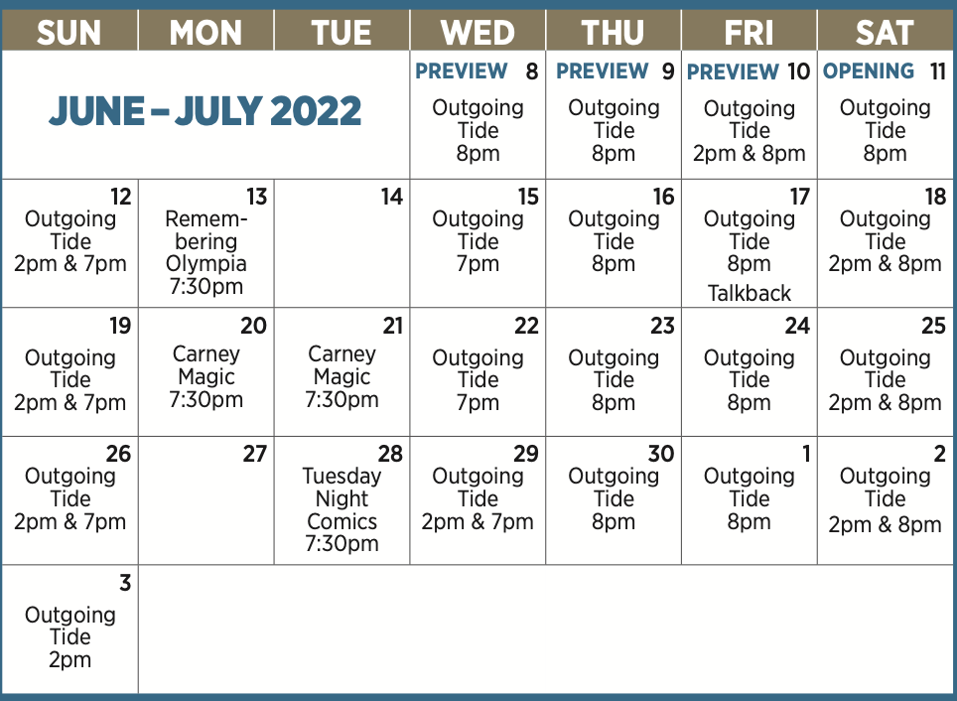

BIOS:

BRUCE GRAHAM (Playwright) his plays include Burkie, Early One Evening At The Rainbow Bar & Grille, Moon Over The Brewery, Minor Demons, Belmont Avenue Social Club, The Champagne Charlie Stakes, Desperate Affection, Coyote On A Fence (Winner of The Rosenthal Prize, Two Drama Desk Nominations – the West End production starred Ben Cross), According To Goldman, Dex And Julie Sittin' In A Tree And The Outgoing Tide (which starred John Mahoney and Rondi Reed). Graham recently returned to acting, playing Lenny in his play Any Given Monday, which won the 2010 Barrymore Award for Best New Play. His one man show, The Philly Fan, plays semi-continuously throughout the Philadelphia area. Something Intangible won seven 2009 Barrymore Awards including Best New Play. His film credits include "Dunston Checks In," "Anastasia," and "Steal This Movie." T.V. MOVIES: "Hunt for the Unicorn Killer," "The Christmas Secret," "Ring of Endless Light" (Humanitas Award Winner – Best Children’s Screenplay), "Right on Track," "Tiger Cruise," "The Most Wonderful Time of the Year," "Trading Christmas." TELEVISION: "Roseanne," "Leg Work" and various soap operas. Graham has received grants from the Pew Foundation, the Princess Grace Foundation (Statuette Award Winner) the Rockefeller Foundation and the Philadelphia Theatre Initiative. He is a two time winner of the Edgerton Foundation Award for Best New Play. Along with Michele Volansky he is the author of the book, “The Collaborative Playwright.” Graham is a graduate of Indiana University of Pennsylvania. He teaches film and theatre courses at Drexel University and lives in South Philly with his wife Stephanie, daughter Kendall and beagle Truman.

NIKE DOUKAS (Director) most recently directed All’s Well That Ends Well at A Noise Within, and an online production of the world premiere of Jake Broder’s UnRavelled. Pre-pandemic projects include: the world premiere of Steven Leigh Morris’s Red Ink, at Playwright’s Arena in Los Angeles, King Lear at the Harold Clurman Laboratory Theatre, and Harold Pinter’s The Hothouse, at the Antaeus Company (nominated for 10 Ovation Awards and 4 Drama Critic Circle Awards). As an actor, she has appeared at South Coast Repertory, The Geva Theatre, The Pasadena Playhouse, The Mark Taper Forum, The Old Globe, The American Conservatory Theatre, (MFA in Acting), The Berkeley Repertory Theatre, ACT (Seattle), The LA Shakespeare Festival, The Berkeley Shakespeare Festival, and Shakespeare Santa Cruz, among others. Nike is also Head of Acting at the Art of Acting Studio, where she teaches and directs. Her numerous guest star appearances on television, include a recurring role on “Desperate Housewives.” She is a 2011 Lunt Fontanne Fellow, awarded to regional theatre actors for excellence.

ANDREW BARNICLE* (Gunner) has acted Off-Broadway and in regional theatres around the country, as well as in film and television. Most recently he performed in Beauty and The Beast: A Christmas Rose, Twelve Angry Men and Fallen Angels at the Laguna Playhouse, as General Sickles in Faded Glory, Tomfoolery, Sherlock Holmes And The Adventures of the Great Nome Gold Rush, and Amadeus at North Coast Repertory Theatre. He was the artistic director for nineteen years at The Laguna Playhouse, and he was the associate artistic director at North Coast Rep in the 1980’s. He has produced more than 120 professional productions, directed more than 75, (including 13 at NCRT), and acted in over 30. He has been a proud member of Actors’ Equity since 1981.
LINDA GEHRINGER* (Peg) has made numerous.appearances at South Coast Repertory in many new plays and world premieres. She also went to New York for the premiere of Jenny Chow at the Atlantic Theatre Company with the company. She has acted in theatres across the country, most recently in the world premiere of the one-woman show, Lady in Denmark, at Chicago’s Goodman Theatre; the world premieres of Vicuña at Kirk Douglas Theatre; The Comparables at Seattle Repertory Theatre; Surf Report and Light Up the Sky at La Jolla Playhouse; The Women and Since Africa at The Old Globe; and The Crowd You’re In With (Jeff Award nomination) at Goodman Theatre. Her recent television credits include “Fear the Walking Dead,” “Grey’s Anatomy,” “Perry Mason” (HBO), “Physical "and recurring roles on “Touch” and “Justified.” Her other television work includes “NCIS,” “Raising Hope,” “Weeds,” “Gilmore Girls,” “Without a Trace,” “Cold Case,” “Ally McBeal,” “Frasier,” and “The West Wing,” and the films “Into the Storm,” “Kreep,” and “As Good As It Gets.”

LEO MARKS* (Jack) Most recently Leo played every resident of Bedford Falls in This Wonderful Life, a one-man It’s a Wonderful Life with Rogue Machine. Other credits include Mysterious Circumstances at the Geffen Playhouse, Everything That Never Happened and The Missing Pages of Lewis Carroll at Theatre at Boston Court, How to Write a New Book for the Bible at Berkeley Rep and Seattle Rep (with Linda Gehringer!), inaugural productions at the Kirk Douglas Theater and A.C.T.’s The Strand, Lincolnesque, and Time and the Conways at The Old Globe, The Language Archive, Smokefall, and Major Barbara at South Coast Rep, as well as productions at D.C.’s Shakespeare Theater, Cleveland Playhouse, Actors Theater of Louisville, Pasadena Playhouse, Ahmanson Theatre, The Intiman, PICT, Alley Theatre, and Playwrights Horizons. Founding member, New York’s Elevator Repair Service, and proud member of Antaeus. Awards include an Obie for Heather Woodbury’s Tale of 2Cities: An American Joyride on Multiple Tracks.
AARON RUMLEY* (Performance Stage Manager/Sound Designer) has worked on over 120 shows at North Coast Rep, over 50 as a stage manager, over 20 as a designer.
CREATIVE STAFF
MARTY BURNETT (Set Design) Resident Designer at North Coast Rep since 1992 and has designed more than 200 productions for the theater. Other design venues include Sahara and Hacienda hotels in Las Vegas, Claridge Hotel, Atlantic City and Drury Lane Chicago.
MATTHEW NOVOTNY (Light Design) is pleased to be designing another show for North Coast Rep, where he has designed close to forty shows over the past seven years. Matthew is currently the Lighting Designer in Residence for San Diego Musical Theatre as well as North Coast Rep, and his work can be seen at a wide variety of theatres across San Diego. Matthew holds a B.A. in Technical Theatre from San Diego State and a master’s degree in Lighting Design from Boston University. Matthew is married to his beautiful wife Amanda, with 5 AMAZING children: Ragan, Harper, Heston, Maddex and Harrison .
ELISA BENZONI+ (Costume Design) is thrilled to be working on her fourth season at North Coast Rep including numerous Craig Noel nominated productions. Elisa has also worked on over a hundred productions across Southern California with theatres such as The Old Globe, La Jolla Playhouse, Geffen Playhouse, South Coast Repertory Theatre, Laguna Playhouse, San Diego Repertory Theatre, Diversionary Theatre and New Village Arts. Being Italian-born, Elisa has also had the opportunity to work and perfect her craft in Europe. Elisa holds a costume design M.F.A. from UCSD where she currently is an adjunct professor. www.elisabenzoni.com
PHILLIP KORTH (COVID-19 Compliance Officer/Props) is an actor, writer, craftsman, and educator. He earned BAs in Acting and Creative Writing from Western Michigan University and his MFA in Acting from the University of Connecticut. He is a Veteran of the United States Marine Corps and served two tours of duty in Iraq. In addition to designing and managing props for NCRT, Phillip is also the Education Associate at The Theatre School @ North Coast Rep.
PETER HERMAN (Hair & Wig Design) has previously designed wigs for over 30 North Coast Rep productions. Peter teaches wig and makeup design at San Diego State University. He is glad to be part of the creative team on this show.
About the North Coast Repertory Theatre under the artistic leadership of David Ellenstein since 2003, is a professional Equity theatre, currently celebrating its 40th Season. North Coast Rep has received critical acclaim from media and audiences alike, and has evolved into one of the area’s leading performing arts organizations. North Coast Rep prides itself on employing the majority of its actors from Actors’ Equity Association for its high quality, award‐winning productions, and staging works by established and emerging playwrights. Throughout its history, North Coast Rep has created a platform where artist and audience thrive through the intimacy of live theatre, recognizing the power of theatre to challenge complacency, revitalize the imagination, nurture the unexpected and embrace the variety and diversity in our lives.
###

